# Project Design Phase-II

**Data Flow Diagram & User Stories**

|  |  |
| --- | --- |
| Date | 17 October 2022 |
| Team ID | PNT2022TMID43466 |
| Project Name | Emerging Methods for Early Detection of Forest Fires |
| Maximum Marks | 4 Marks |

## Data Flow Diagrams:

A Data Flow Diagram (DFD) is a traditional visual representation of the information flows within a system. A neat and clear DFD can depict the right amount of the system requirement graphically. It shows how data enters and leaves the system, what changes the information, and where data is stored.

## Example:

FLOW  It is difficult to predict and detect Forest Fire in a sparsely populated forest area.

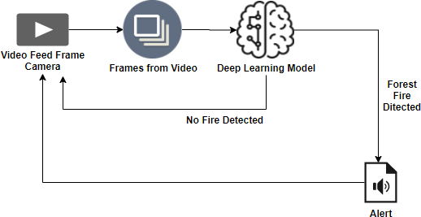 it is more difficult if the prediction is done using ground-based methods using Camera or video recorder.

 Satellites can be an important source of data prior to and during the Fire due to its reliability and efficiency.

 There various real-time forest fire detection and prediction approaches, with the goal of informing the local fire authorities.

 If the fire is not detected, it will send the result to the frame camera. If a forest fireis detected the alert will go to the video feed frame camera.

# DFD:

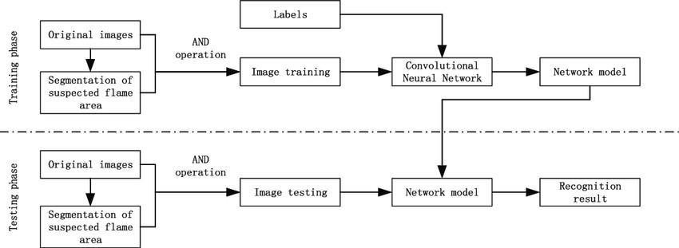

## User Stories

Use the below template to list all the user stories for the product.

|  |  |  |  |  |  |  |
| --- | --- | --- | --- | --- | --- | --- |
| **User Type** | **Functional Requirement (Epic)** | **User Story Number** | **User Story** I **Task** | **Acceptance criteria** | **Priority** | **Release** |
| Environmentalist | Collect the data | USN-1 | Environmentalists help the public make informed decisions about the use of limited natural resources. They do research, produce reports, write articles, lecture, issue press releases, lobby congress, fundraise, and campaign. The daily routine depends on the specialty. | It is necessary to collect the right data else the prediction  maybe inaccurate | High | Sprint-1 |
|  |  | USN-2 | Identify algorithms that can be used for prediction | To collect the algorithm to  identify the accuracy level of each algorithms | Medium | Sprint-2 |
|  | Implement Algorithm | USN-3 | Identify the accuracy of all the algorithms that are being used. | Accuracy of each algorithm-known so that it is easy to make the most efficient prediction. | High | Sprint-2 |
|  |  | USN-4 | Evaluate the Dataset | Data is evaluated before processing | Medium | Sprint-1 |
|  | Evaluate Accuracy of Algorithm | USN-5 | Identify accuracy, precision, recall each algorithm. | These values are important for obtaining the right output | High | Sprint-3 |
|  | Display Results | USN-6 | Output is received from each algorithm. | It is widely used to foresee effects and take preventative action. | High | Sprint-4 |